

**Cairo University**



**Faculty Of Engineering**

Advanced Database System

Report

Ahmed Mohamed Ismail Nabeel 1180501

Mostafa Ashraf Ahmed 1180406

Moaz Mohamed Elsherbini 1180528

Nader Youhanna Adeb 1180477

Table of Contents

Query 1 3

# System Information

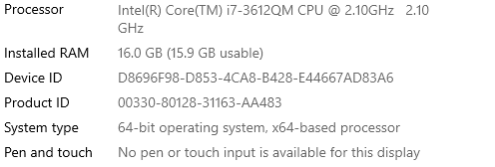

Operating System: Windows 10 Pro

Hard disk: 5400 RPM 1 TB hard disk

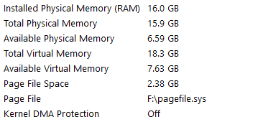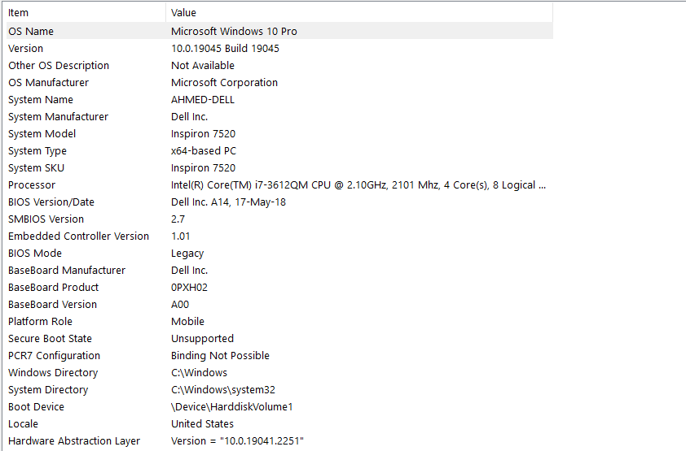

# Query 1

## Before Optimization



### Execution Plan

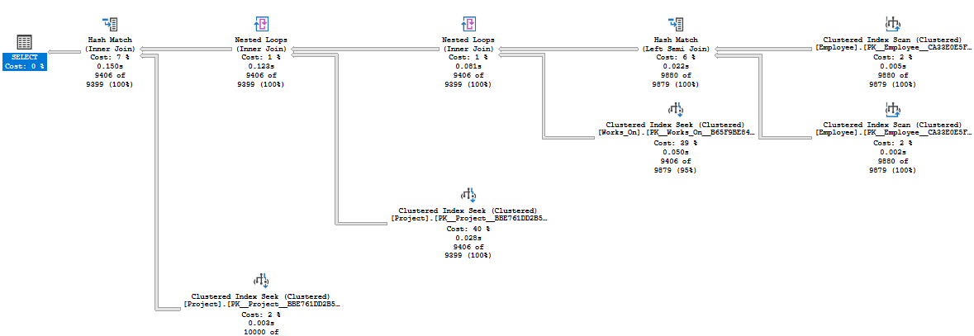

## After Optimization



### Execution Plan

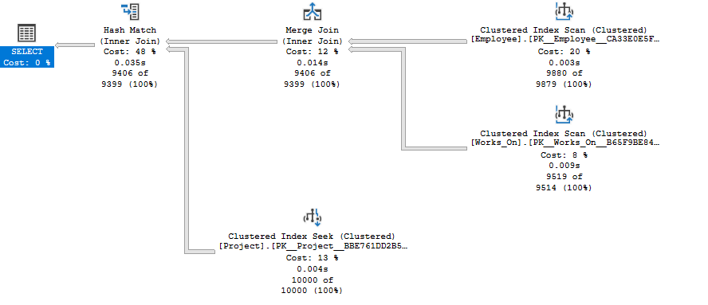

## Optimization Done

* INNER JOIN instead of NESTED LOOP JOIN
* Non-clustered index on Ssn & Pnumber

|  |  |  |
| --- | --- | --- |
| Action | CPU Time (s) | Elapsed Time (s) |
| Query 1 (No optimization) | 0.688 | 2.180 |
| Query 1 (Optimized INNER JOIN) | 0.136 | 2.106 |
| Adding non-clustering index | 0.123 | 1.902 |
| NoSQL MongoDB | 2.223 |  |

## Theoretical Parallel Query Processing Report

* Clustered index scan on Employee table
* Clustered index scan on Project table
* Clustered index scan on Works_On table

# Query 2

# NoSQL Queries

# Query 1

